Class Time:
Names:

The Chi Square Distribution: Chi-Square Goodness of Fit Lab

Student Learning Outcome:
The student will evaluate data collected to determine if they fit either the uniform or exponential distributions.
Collect the data:
Go to your local supermarket. Ask 30 people as they leave for the total amount on their grocery receipts. (Or, ask 3 cashiers for the last 10 amounts. Be sure to include the express lane, if it is open.)

- Record the values.

- Construct a histogram of the data. Make 5 - 6 intervals. Sketch the graph using a ruler and pencil. Scale the axes.
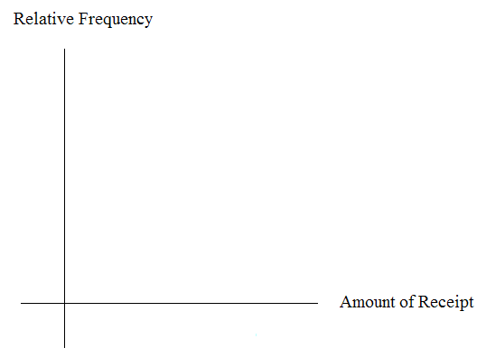
- Calculate the following:
- = __________
- s = __________
- s2 = _________
Uniform Distribution
Test to see if grocery receipts follow the uniform distribution.
- Using your lowest and highest values, X ~ U( _______, _______ )
- Divide the distribution above into fifths.
- Calculate the following
  - lowest value = _______
  - 20th percentile = _______
  - 40th percentile = _______
  - 60th percentile = _______
  - 80th percentile = _______
  - highest value = ________

- For each fifth, count the observed number of receipts and record it. Then determine the expected number of receipts and record that.
Fifth | Observed | Expected
1st
2nd
3rd
4th
5th

- H_{o}:

- H_{a}:

- What distribution should you use for a hypothesis test?

- Why did you choose this distribution?

- Calculate the test statistic.

- Find the p-value.

- Sketch a graph of the situation. Label and scale the x-axis. Shade the area corresponding to the p-value.
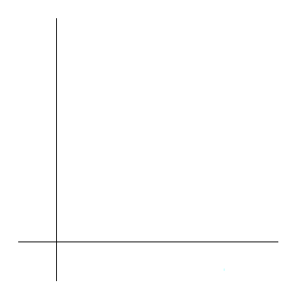
- State your decision.

- State your conclusion in a complete sentence.

Exponential Distribution
Test to see if grocery receipts follow the exponential distribution with decay parameter 1/ .
- Using 1/ as the decay parameter, X ~ Exp(_______)
- Calculate the following.
- lowest value = __________
- first quartile = __________
- 37th percentile = __________
- median = __________
- 63rd percentile = __________
- 3rd quartile = __________
- highest value = __________
- For each cell, count the observed number of receipts and record it. Then determine the expected number of receipts and record that.

Cell | Observed | Expected
1st
2nd
3rd
4th
5th
6th

- H_{o}

- H_{a}

- What distribution should you use for a hypothesis test?

- Why did you choose this distribution?

- Calculate the test statistic.

- Find the p-value.

- Sketch a graph of the situation. Label and scale the x-axis. Shade the area corresponding to the p-value.
- Decision

- State your conclusion in a complete sentence.

Discussion Questions
- Did your data fit either distribution? If so, which one?

- In general, do you think it’s likely that data could fit more than one distribution? In complete sentences, explain why or why not.

